SOCIAL TEXT MESSAGING TOOL

Introduction :
Our Application is a real-time information network powered by people all around the world that lets you share and discover what’s happening now.

Our Application asks “what’s happening” and makes the answer spread across the globe to millions, immediately.

What our application Does :
Whether it’s breaking news, a local traffic jam, a deal at your favorite shop or a funny pick-me-up from a friend, Our application keeps you informed with what matters most to you today and helps you discover what might matter to you most tomorrow.
The timely bits of information that spread through Our application can help you make better choices and decisions and, should you so desire, creates a platform for you to influence what’s being talked about around the world. Search results spread across Our application and in other ways across the Web so you can discover what’s happening on and off of Our application.com, wherever you prefer.
Just remember, how you use Our application is completely up to you. Follow hundreds of people. Follow a dozen. Post every hour. Post never. Search for your favorite topics and create lists. Or not. You are in control on Our application.

Our application for Business :
Our application is a simple tool that helps connect businesses more meaningfully with the right audience at the right time.
Businesses and organizations of all shapes and sizes are now able to stay connected to their customers. It can be used to quickly share information with people interested in your company, gather real-time market intelligence and feedback, and build relationships with customers, partners and other people who care about your business. Customers can use Our application to tell a company (or anyone else) that they’ve had a great—or disappointing—experience with your business, offer product ideas, and learn about great offers they’ve selected to be notified of.

New features than Existing System:
1. In existing application message sharing is available between their users only. In my application facebook,linkedin and digg share is available. So users can share their message with all world major social media's(facebook,linkedin,google buzz and digg).
- Easy to registration
- Public profile to users

Modules:
    - Login
    - Registration
    - Forgot password
    - Posting message
    - Follwers
    - Followings
    - Listing
    - Public profile
    - Share with social media market
    - Application Admin panel
    - Profile
    - Edit profile
    - Reshare
    - Invite friends
    - Setting
    - Help
    - Search

Login:
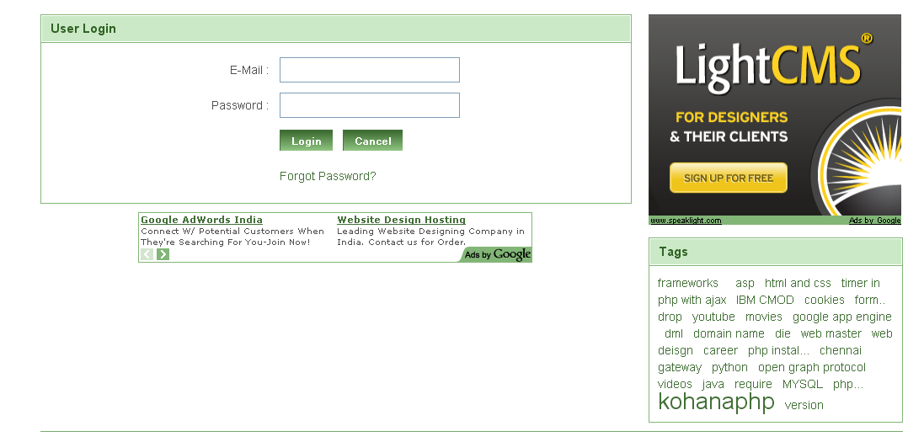

Signup:
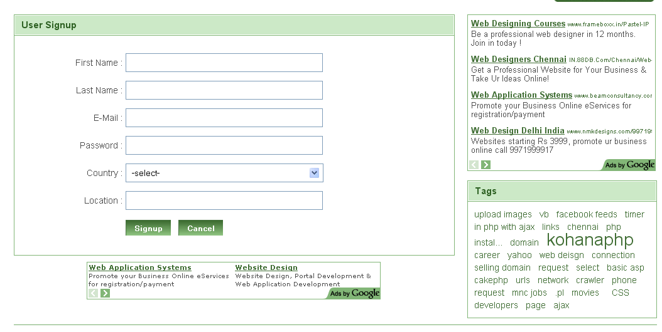

Forgot password:
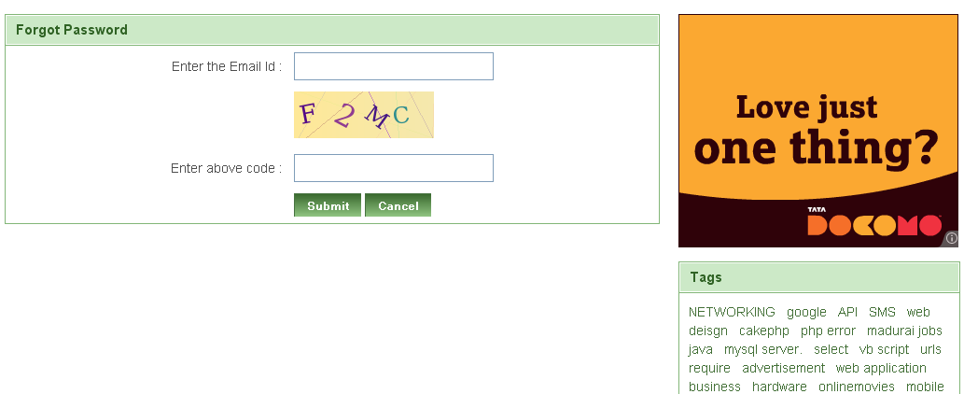

Profile:
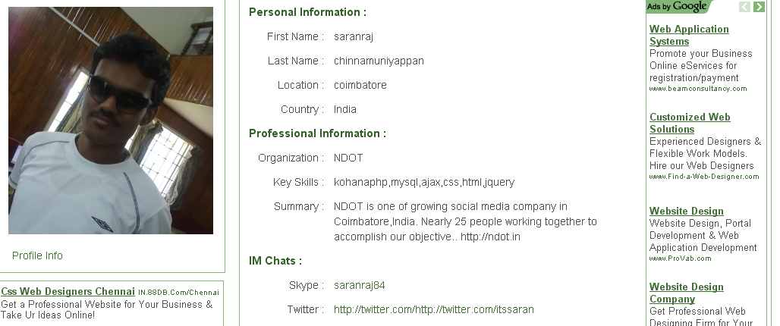

Edit Profile:

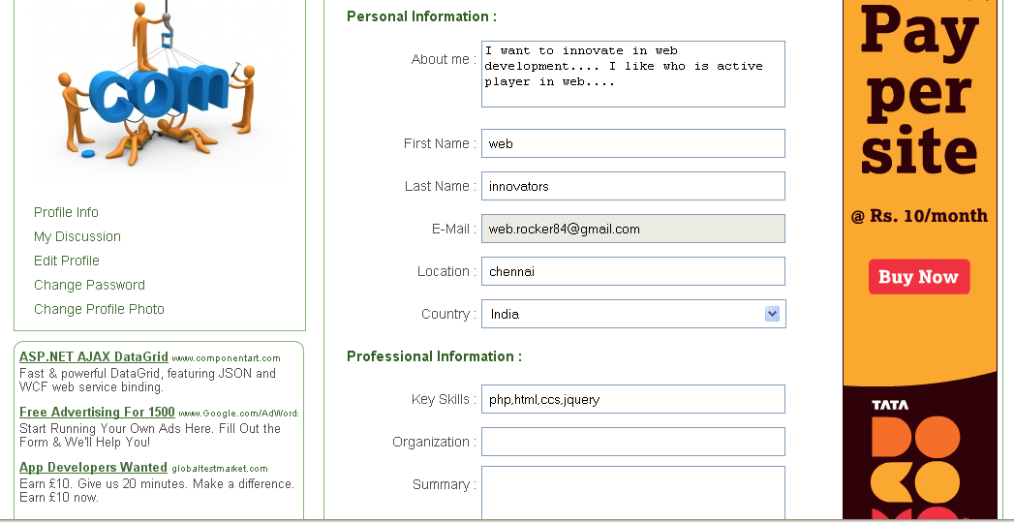
Contact Us:
Change Photo:

Admin panel:

